JUNIOR OLYPIAD CHEMISTRY JETS 2012
QUESTION 1
Some reactions of metals W,X,Y and Z are given below.
METAL | REACTION WITH WATER | REACTION WITHDILUTE HYDROCHLORIC ACID
W | A few bubbles from slowly in cold water. | Vigorous reaction. Gas given off
X | Vigorous reactions. Metals melts. Gas given off. | Explosive reaction should not be attempted.
Y | No reaction | No reaction
Z | Does not react with cold water. Hot metal reacts with steam | Steady fizzing

(a) arrange these metals in order of reacting.
Most reactive…………………………………………………….[1]
Least reactive…………………………………………………….[1]
(b) which of these metals could be
(i) Magnesium…………………………………………………………[2]
(ii) Copper……………………………………………………………….[2]
(c) the equation for the reaction of X with cold water is given below.
2X(s)+2H₂O→2XOH(aq)+H₂(g)
(i) Describe the test you would use to show that the gas evolved is hydrogen…………………..[2]
(ii) How could you show that the water contained a compound of the type XOH………………[2]
(iii) In which group of the periodic table does metal X belong?..............................................[2]
(iv) The ore of X is its Chloride. Suggest how metal X could be extracted from its Chloride?[2]
SOLUTIONS.
(a) X W Z Y
-For most reactive X and least Y
-All other responsesl0]
(b) Magnesium W
Copper Y
(c) (i) goes “pop” with burning splint or mixed with air and ignited goes pop.
Not glowing splint.
(ii) test and observe results
Universal indicator goes blue or PH paper goes blue or high PH,accept13,14 or with metallic cations
Forms a precipitate.
Not litmus, only accept neutralizes acids with an observable results, e.g becomes warm.
(iii) Group 1
(iv) electrolysis
Question 2
Copper is purified by electrolysis.
(a)Complete the following:
The positive electrode(anode)is made from……………………………………………………………………………..[2]
The negative electrode(cathode)is made from…………………………………………………………………………..[2]
The electrolyte is aqueous………………………………………………………………………………………………………….[2]
(b)Give two reasons why copper is used,
(i) in electric wiring……………………………………………………………………………………………………………………..[1]
(ii)in cooking utensils………………………………………………………………………………………………………………….[1]
(iii)give another use of copper…………………………………………………………………………………………………….[1]
(c)Choose a gas from the following list to answer the questions below.Each gas may be used once,more than or not at all.
Ammonia,argon,carbondioxide,chlorine,ethane,hydrogen.nitrogen and oxygen.
(i)is a noble gas………………………………………………[1]
(ii)is an acidic oxide……………………………………….[1]
(iii)can be polymerized…………………………………[1]
(iv)is an active component of air………………………………..[1]
(v)is used in the treatment of water……………………………..[1]
(vi)is a product of respiration………………………………………..[1]
ANSWERS TO QUESTION 2
(a)impure copper
Pure copper
NB: accept any(soluble)copper salt or Cu²⁺ if both name and formulae given,both have to be correct.
(b)(i)good conductor
Malleable or ductile
(ii)good conductor of heat
High melting and boiling points
Unreactive or resists corrosion
(iii)appearance(any two)
Do not accept malleable or ductile if either is given for wiring.
Alloys or named alloys or boilers or pipes or ornaments etc
(c)(i) argon
(ii)carbon dioxide
(iii)ethane
(iv)oxygen
(v)chlorine
(vi)carbon dioxide
QUESTION 3
(a)State what is meant by:
(i)proton number
(ii)nucleon number
The table below shows atoms of five elements,V,W,X,Y and Z.The letters are not actual symbols.The atomic numbers and mass numbers of the elements are given.
Element | Atomic number | Mass number
V | 16 | 32
W | 18 | 40
X | 17 | 37
Y | 16 | 34
Z | 12 | 24
(b)State,with a reason,which element(s) is
(i)a halogen………………………………………………………..[1]
Reason……………………………………………………………..[1]
(ii)a metal……………………………………………………………..[1]
Reason……………………………………………………………..[1]
(iii) are isotopes…………………………………and………………………………[2]
Reason………………………………………………………[1]
(c)(i)What is the principle valency of element V?..........................[1]
(ii)Write the formula of the compound formed when V combines with X…….[1]
(iii)Draw the electronic structure to show the bonding in the compound formed in (c)(ii)above.(show outer electrons only)
(d)(i)How does element Z form an ion?.................................[1]
(ii)Write the formula for the ion of Z. [1]
ANSWERS TO QUESTION 3
(a)(i)the total number of protons in an atom.
(ii)the sum of protons and neutrons in an atom.
(b)(i)X [1] – Because it has 7 electrons in its outermost shell. [1]
(ii) Z [1] – Because it ionizes by losing 2 electrons (as it has 2 electrons in its outermost shell) [1]
(iii) V and Y [2] - They have the same proton numbers. [1]
( c ) (i) 4 [1]
(ii) V$X_{4}$ . [1]
(iii)

(d)(i) By electron loss(losing 2e in its outermost shell)
(ii)Z²⁺
QUESTION 4
(a) Name the method which would be used to extract the following metals from their ores:
(i)Magnesium…………………………[1]
(ii)Zinc…………………………………..[1]
(b)Iron is extracted from its ore in the blast furnace.
(i)Name the other two raw materials needed for the extraction of iron…………………………………………..[2]
(ii)What name is given to the three raw materials(iron ore, and those named in (b)(i)above, collectively…………………………..[1]
(iii)Construct a chemical equation for the reaction in which the gaseous reducing agent in the blast furnace takes place. [2]
(iv)What is the role of the hot waste gases that leave the blast furnace?...........................................[1]
(c)Copper(II)sulphate solution can react with calcium metal according to the reaction:
CuSO₄(aq)+Ca(s)→CaSO₄(aq)+Cu(s)
(i)is copper more or less reactive than calcium? Explain your answer. [2]
(ii)How would you tell that the reaction between copper(II)sulphate and calcium has occurred? [2]
(iii)What term describes the above reaction?.......................................................................................[1]
(d)Name two uses of noble gases……………………………………………………………………………………………………….[2]
ANSWERS TO QUESTION 4
(a)(i)Electrolysis
(ii)Reduction by heating with a reducing agent.
(b)(i)-coke(carbon)
-Limestone(calcium carbonate)
(ii)Charge
(iii)Fe₂O₃+3CO→2Fe +3CO₂
(iv)To preheat the hot air blast.
(c)(i) less reactive
Because it has been displaced by calcium.
(ii)When the colour of the solution(mixture)changes from blue to colourless.
(iii)Displacement reaction
(d)Argon-to provide inert atmosphere in chemical plant.
-in light bulbs to provide inert atmospheres
Neon-in advertising lasers and signs.
Helium-in hot air balloons.
Question 5
(a)The melting and boiling points of six substances are given below.
Substance m.p/⁰C b.p/ºC
Nitrogen -210 -196
Carbon disulphide -112 46
Ammonia -78 -34
Bromine -7 59
Phosphorus 44 280
Mercury chloride 276 302
(Room temperature is taken at 20⁰C)
(i)Which element is a solid at room temperature?[1]

(ii)Which compound is a liquid at room temperature?[1]
(iii)Which compound is a gas at room temperature?[1]
(iv)Which element will condense when cooled to room temperature from 100⁰C?[1]
(v)Which compound will freeze first on cooling from room temperature to a very low temperature? [1]
(vi) Which of the six substances is a liquid over a widest range of temperature? [1]
(vii) Draw diagrams to show how the particles are arranged in bromine and in ammonia at room temperature and pressure. [4]
(b) Using the ideas of the kinetic theory explain why:
(i) a sample of water left in a dish at room temperature will evaporate over a period of time. [3]
(ii) a metal expands on heating [2]
ANSWERS TO QUESTION 5
(a) (i) Phosphorus
(ii) Bromine
(iii) Ammonia/ Nitrogen
(iv) Bromine
(v) Mercury chloride
(vi) Bromine
(vii) Carbon disulphide
(viii)
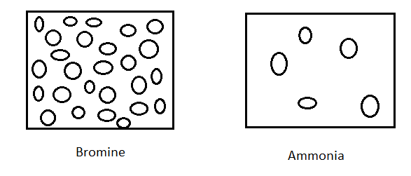
(b) (i) Molecules continuously collide each other in elastic collisions and particles that gain enough energy escape from liquid to gas phase.
(ii) With increased thermal energy of particles, the vibration dimensions increase and so substance size consequently increases.

QUESTION 6
(a) Elements can be divided into metals and non metals according to their physicacal properties. Metals in general have a luster, are solid at room temperature, malleable and ductile.
(i) Give two other physical properties of metals not mentioned above………………………………….[2]
(ii) What is the meaning of the following terms:
- Lustre …………. [1]
- Malleable………. [1]
- Ductile …………… [1]
(b) The chemical properties of elements are also used to distinguish between metals and non-metals. Most metals react with acids.
(i) Write a word equation of the reaction of magnesium with dilute hydrochloric acid. [2]
(ii) Write a balanced chemical equation for the reaction in (b) (i) above [2]
(iii) Name one metal which reacts dangerously with a dilute acid. [1]
(iv) Name one metal which does not react with dilute acids. [1]
(c) Sodium reacts with cold water violently.
(i) Write down the names of the two products of this reaction. [2]
(ii) Write down the electronic configuration of a sodium atom. [2]
ANSWERS TO QUESTION 6
(a) (i) strong under tension and compression/ sonorous/ good conductors etc
(ii) -They are reflective and shiny
- Can be hammered and bent into shapes
- Can be drawn out to make wires
(b) (i) Magnesium + hydrochloric acid Magnesium chloride + hydrogen gas
(ii) Mg + 2HCl MgCl₂ + H₂
(iii) Sodium/ any alkali metal
(iv) Lead/copper/silver/ gold/mercury
(c) (i) Sodium hydroxide and hydrogen gas
(ii) 2,8,1
QUESTION 7
(i) A grade 9 pupil carried out an experiment on the nails rust. He set up the apparatus as shown below:
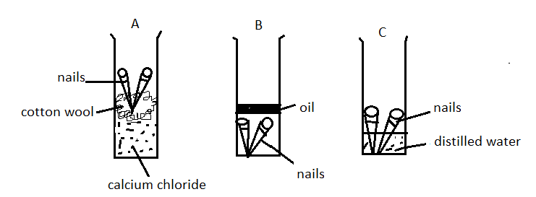
(a) In which tubes did the nails rust? [1]
(b) Rust is hydrated iron III oxide. What does this mean? [1]
(c) Write a word equation of the reaction in which rust is formed. [2]
(d) State two factors which are needed for an iron nail to rust. [2]
(e) Give a reason for the use of the following in the experiment:
(i) cooking oil [1]
(ii) anhydrous calcium chloride [1]
(f) State whether rusting is oxidation or reduction or none [1]

(ii) Study the diagram blow:
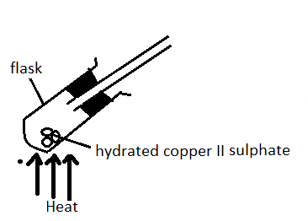
(a) State colour change that happened to the copper II sulphate after some minutes. [1]
(b) Write the word equation to represent the physical change which is happening in the flask. [1]
(c) 4g of hydrated copper II sulphate was used in the experiment. After heating, the remained copper II sulphate weighed 2.6g. What was the percentage of water of crystallization contained. [3]
(d) state the chemical test for water. [1]
ANSWERS TO QUESTION 7
(i) (a) C
(b) Iron III oxide contains water of crystallization
(c) Iron + Oxygen hydrated iron III oxide
(d) Oxygen and water
(e) (i) Cooking oil is used to exclude oxygen/air from the tube
(ii) anhydrous calcium chloride is a drying agent. It removes all the moisture from the tube
(f) Oxidation
(ii)(a) blue to white
(b) hydrated copper II sulphate anhydrous copper II sulphate + water

(c)
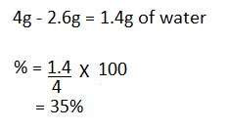
(d) It turns white anhydrous copper II sulphate to blue/ It turns blue cobalt chloride paper to pink.
QUESTION 8
(a) Outline four characteristics of a solid [4]
(b) When a metal such as copper is heated it expands. Explain what happens to the metal particles as it expands. [2]
(c) Name the three fundamental particles of an atom. [3]
(d) What is the other name for electron shells of an atom? [1]
(e) State three differences between boiling and evaporation. [3]
(f) What do we call a concentrated sodium chloride solution? [1]
ANSWERS TO QUESTION 8
(a)-has a definite volume
- expand when heated
- contract when cooled
- has a fixed shape
(b) When solids are heated the particles gain kinetic energy and vibrate fast.
(c) protons, neutrons and electrons.
(d) energy levels
(e) - Boiling occurs at boiling point while evaporation at any temperature.
- Boiling occurs though out the liquid while evaporation at the surface
- Boiling requires heat energy while evaporation does not.
(f) brine

